Ropery Walk Science Curriculum Overview
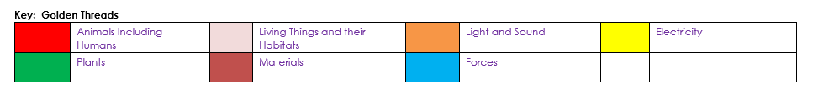

 | Autumn | Spring | Summer
EYFS | Understanding the World  The Natural World  Body parts  Senses  Changing Season  People, Culture and Communities  Talking about ourselves and our family.  The Natural World  Materials and their properties.  Planting beans and observing growth.  Draw and label parts of a plant.  Changing Season | The Natural World  Floating and sinking.  Changing states of matter (Freezing/melting)  The Natural World  Life cycles of plants.  Drawing and labelling animals.  Changing Season. | The Natural World  Life cycle of a butterfly/frog. Finding, naming and sorting minibeasts.  Draw/make observations of minibeasts  The Natural World Explore local beach.  Contrast with other locations around the world.  Changing Season  Make ice lollies.
Year 1 | Everyday Materials  Seasonal Changes – Autumn/Winter | Animals Including Humans (Human body and senses)  Animals Including Animals (Animals) | Plants  Seasonal Changes – Spring/Summer
Year 2 | Uses of Everyday Materials  Animals Including Humans | Living Things and their Habitats  Continued. | Plants  Continued
Year 3 | Animals Including Humans  Light | Forces and Magnets  Forces and Magnets cont. | Plants  Rocks and Soils
Year 4 | Sound  Electricity | Animals Including Humans  Animals Including Humans cont | Living Things and their Habitats  States of Matter
Year 5 | Earth and Space  Forces | Properties and Changes of Materials  Properties and Changes of Materials cont. | Living Things and their Habitats – Life Cycles and Reproduction  Animal Including Humans –Changes Growth and Development
Year 6 | Living Things- Classification  Animals Including Humans | Animals Including Humans  Evolution and Inheritance | Light  Electricity

